\*Split the column CITY and separate the code associate with each city

\*Extract the first name from EMPLOYEE NAME column and transform the column.

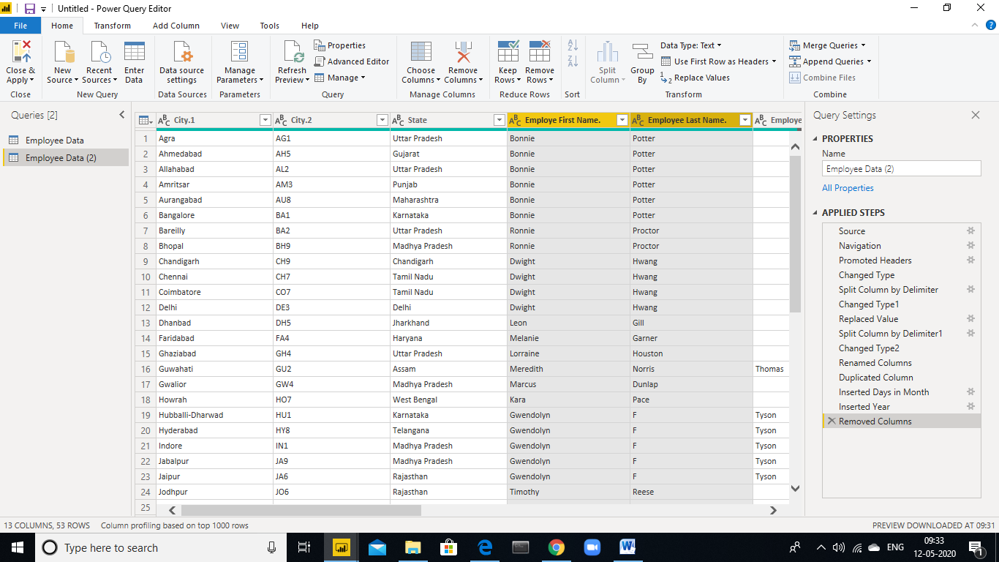

\*Extract the first name from EMPLOYEE NAME column and transform the column.

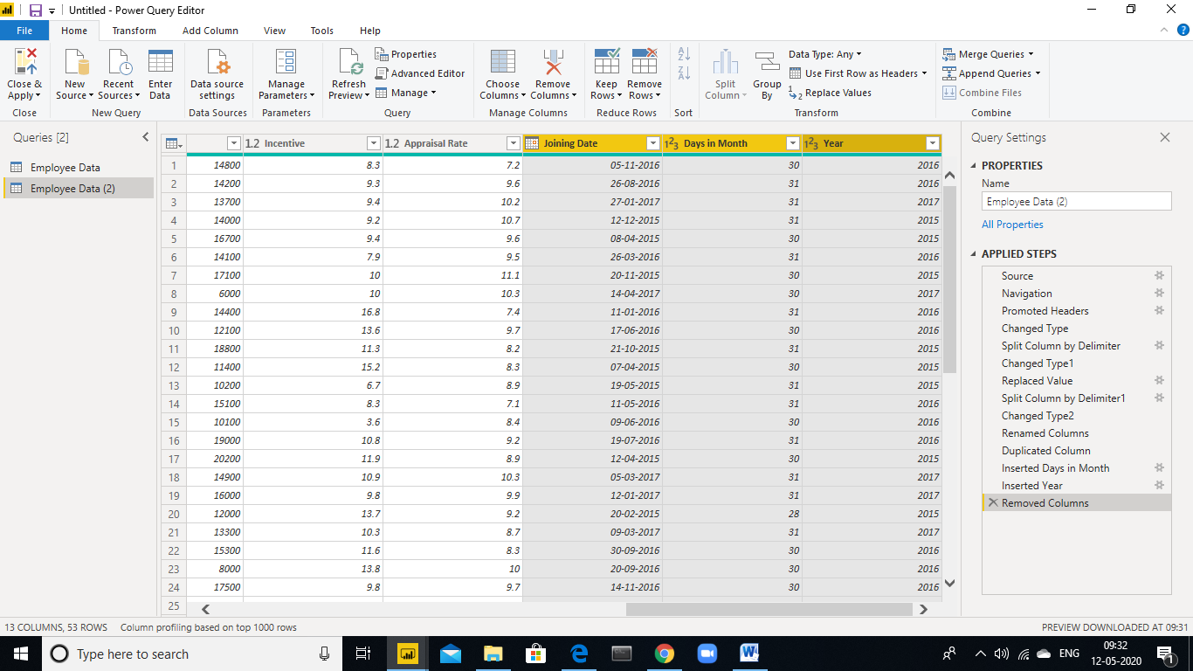

\*Create a visual of your choice and show the how much salary has been paid to each state and which state has lowest payout.

